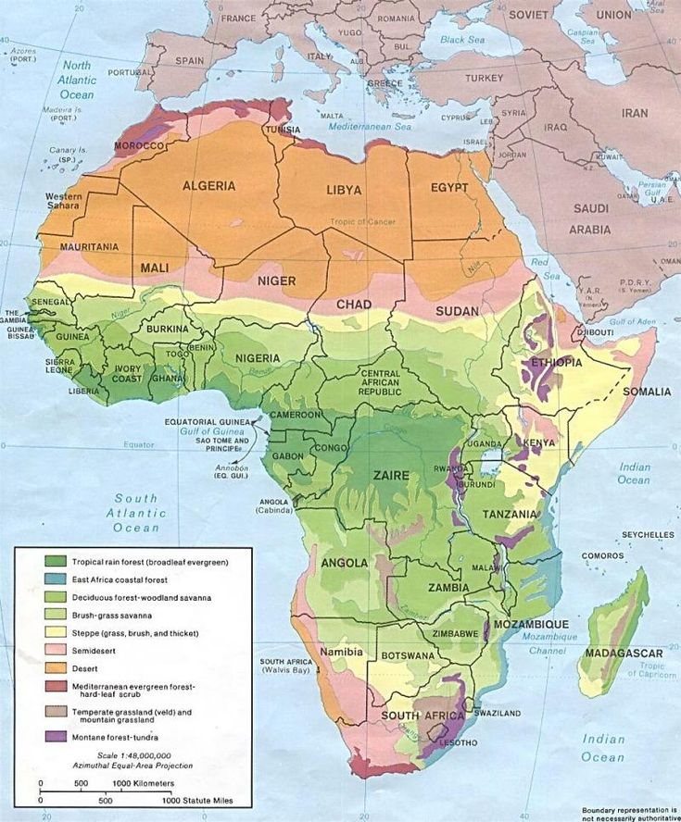
VEGETATIONS REGIONS IN AFRICA

